 museum app and its interactive audiovisual guide. If you’ve worked up an appetite – there are 8,000 objects on display here, so it’s inevitable – make sure to check out the Michelin-starred restaurant and café on site.

[**Read more**](https://www.timeout.com/amsterdam/museums/rijksmuseum)

[**Book online**](https://activities.timeout.com/rijksmuseum-l2696/)

**An email you’ll actually love**

Get into a relationship with our newsletter. Discover the best of the city, first.

Начало формы

Enter email address



Конец формы

By entering your email address you agree to our [Terms of Use](https://www.timeout.com/terms-of-use) and [Privacy Policy](https://www.timeout.com/privacy-notice) and consent to receive emails from Time Out about news, events, offers and partner promotions.

[[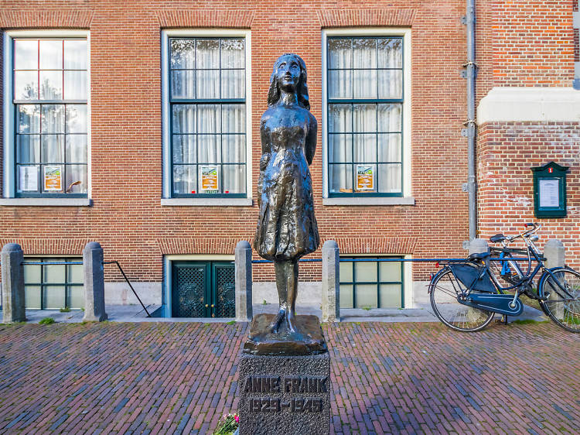](https://www.timeout.com/amsterdam/attractions-and-museums/anne-frank-huis)](https://www.timeout.com/amsterdam/attractions-and-museums/anne-frank-huis" \t "_blank)

[Photograph: Shutterstock](https://www.timeout.com/amsterdam/attractions-and-museums/anne-frank-huis" \t "_blank)

**[2. Anne Frank Museum](https://www.timeout.com/amsterdam/attractions-and-museums/anne-frank-huis" \t "_blank)**

* **Museums**



A sombre reminder of the horrors of the Second World War, the house where Anne and her family hid for two years from the Nazis is now a poignant educational centre and museum. Here you can not just learn about the Holocaust and life under German occupation, but also reflect on persecution and discrimination more broadly. Tickets must be booked in advance online.

[**Read more**](https://www.timeout.com/amsterdam/attractions-and-museums/anne-frank-huis)

ADVERTISING

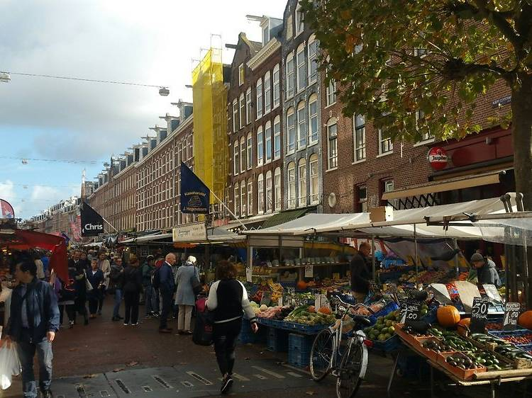

Photograph: Courtesy Yelp/Ann G.

**3. Albert Cuyp Markt**



Their seafaring history has made the Dutch a nation of canny traders, and nowhere is this more evident than down the market. Albert Cuyp, occupying an entire street in grungy De Pijp, is the best in the city, offering meat, fish, veg, souvenirs, bric-à-brac and everything in between. Come down to see the locals do their bantering, bartering best and soak up the bustling atmosphere of one of Amsterdam’s best-loved institutions.

[**Check website**](https://albertcuyp-markt.amsterdam/?lang=en)

[[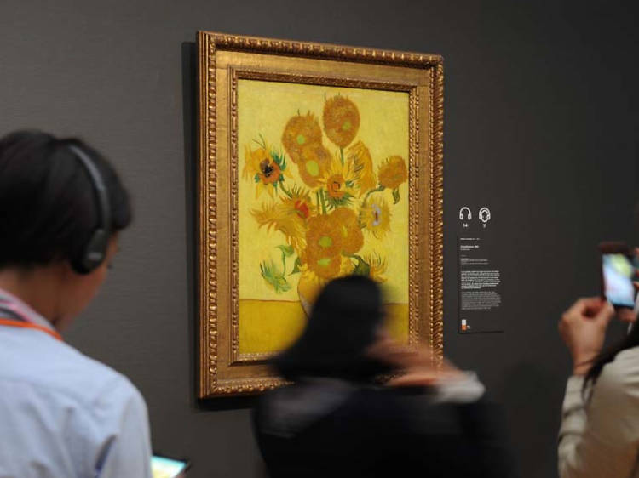](https://www.timeout.com/amsterdam/museums/van-gogh-museum)](https://www.timeout.com/amsterdam/museums/van-gogh-museum" \t "_blank)

[Photograph: Van Gogh Museum](https://www.timeout.com/amsterdam/museums/van-gogh-museum" \t "_blank)

**[4. Van Gogh Museum](https://www.timeout.com/amsterdam/museums/van-gogh-museum" \t "_blank)**

* **Museums**



Misunderstood and penniless for much of his life, Vincent van Gogh only achieved notoriety in death – and veneration much, much later. This specially built museum houses the largest collection of the painter’s work in the world, including ‘The Yellow House’ and ‘The Bedroom’. It’s worth booking a guided tour, and the museum also runs regular workshops and events exploring van Gogh’s life, work and influence on the art world.

[**Read more**](https://www.timeout.com/amsterdam/museums/van-gogh-museum)

[**Book online**](https://www.getyourguide.com/van-gogh-museum-l2695/?partner_id=M7Z0W0W&utm_medium=online_publisher&utm_source=timeout&placement=content-middle)

ADVERTISING

[[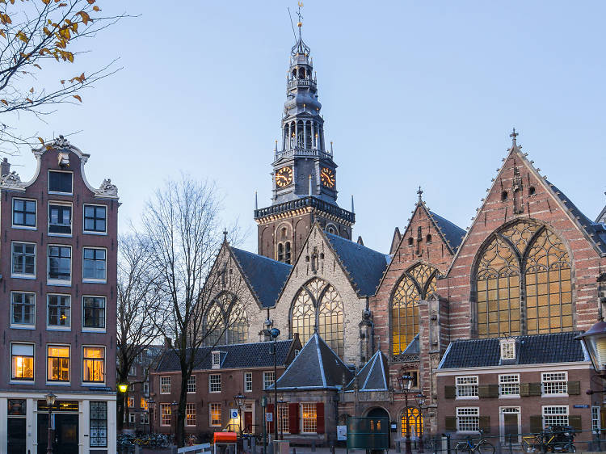](https://www.timeout.com/amsterdam/attractions/oude-kerk)](https://www.timeout.com/amsterdam/attractions/oude-kerk" \t "_blank)

[Photograph: Shutterstock](https://www.timeout.com/amsterdam/attractions/oude-kerk" \t "_blank)

**[5. Oude Kerk](https://www.timeout.com/amsterdam/attractions/oude-kerk" \t "_blank)**

* **Attractions**
* **Historic buildings and sites**
* **Red Light District**



The stone marvel that is Oude Kerk has been around since 1306, withstanding riots, wars and several Reformations; the roof, the largest medieval wooden vault in Europe, dates from 1390. The austere interior is a Calvinist hallmark and is renowned for its acoustics (check their [website](https://oudekerk.nl/en/?gclid=EAIaIQobChMI2_rG_77f4wIVxbHtCh2T8ghrEAAYASAAEgIn6fD_BwE) for upcoming concerts – the sound is spectacular). Don’t miss a trip up the bell tower to glimpse the 17th-century, 47-bell carillon and gaze across the city.

[**Read more**](https://www.timeout.com/amsterdam/attractions/oude-kerk)

[[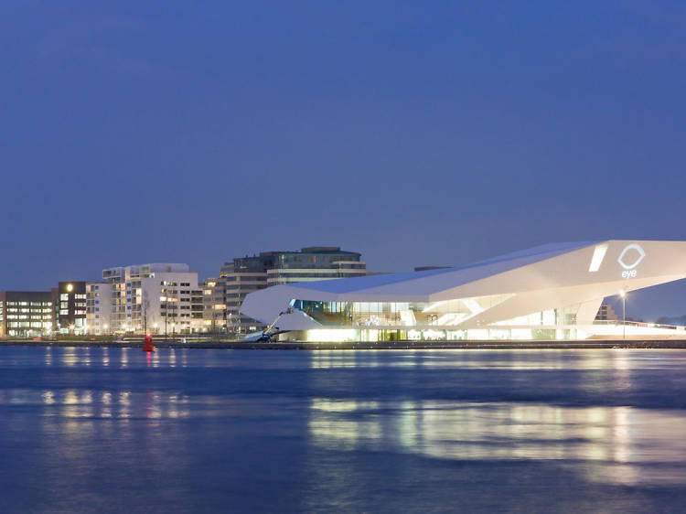](https://www.timeout.com/amsterdam/cinemas/eye-film-institute)](https://www.timeout.com/amsterdam/cinemas/eye-film-institute" \t "_blank)

[Photograph: EYE Film Institute](https://www.timeout.com/amsterdam/cinemas/eye-film-institute" \t "_blank)

**[6. EYE Film Institute](https://www.timeout.com/amsterdam/cinemas/eye-film-institute" \t "_blank)**

* **Cinemas**



The EYE is not simply an eye-catching building worth exploring in its own right, but also a haven for film lovers of all stripes. Temporary exhibitions focus on the cinematic greats, their film archive is second to none, and the diverse programme spans cult classics, themed seasons and films shot in 70mm. Looking for the perfect gift for the cinephile in your life? The superb shop has you covered. And do make time for some refreshment at the riverside café bar – the craft ales are excellent.

[**Read more**](https://www.timeout.com/amsterdam/cinemas/eye-film-institute)

[**Book online**](https://www.eyefilm.nl/en/plan-your-visit)

ADVERTISING

[[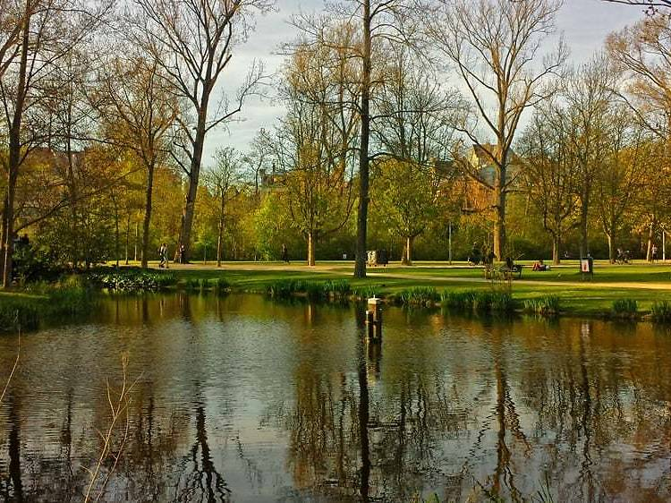](https://www.timeout.com/amsterdam/attractions/vondelpark)](https://www.timeout.com/amsterdam/attractions/vondelpark" \t "_blank)

[Photograph: Courtesy Yelp/Eva T.](https://www.timeout.com/amsterdam/attractions/vondelpark" \t "_blank)

**[7. Vondelpark](https://www.timeout.com/amsterdam/attractions/vondelpark" \t "_blank)**

* **Attractions**
* **Parks and gardens**



For a while, Vondelpark was the only place in the world it was legal to have a barbecue, smoke weed *and* have sex (they’ve now placed restrictions on grilling). But the locals use it for far more than that: jogging, impromptu sports or just a relaxed picnic. If you haven’t brought your own refreshments, there are several excellent cafés – especially [‘t Blauwe Theehuis](https://www.brouwerijhetij.nl/t-blauwe-theehuis/" \t "_blank) – alongside playgrounds and a paddling pool for kids. You might even catch a performance at the park’s famous open-air theatre.

[**Read more**](https://www.timeout.com/amsterdam/attractions/vondelpark)

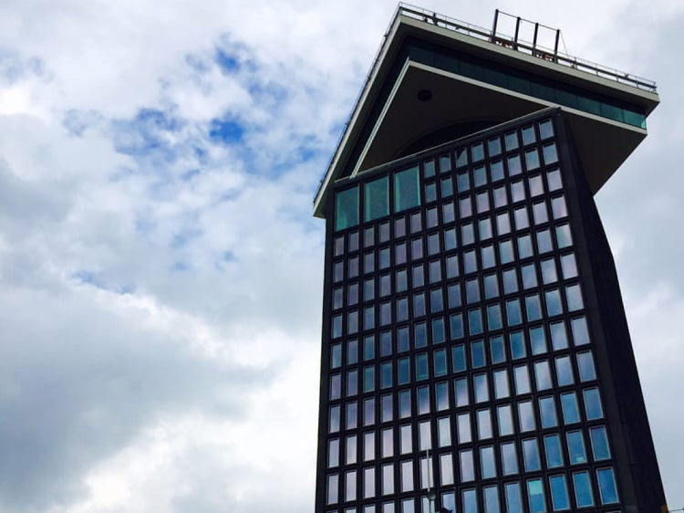

Photograph: Courtesy Yelp/Jessica D.

**8. A’dam Toren**



This spectacular addition to the city’s skyline is also one of the most innovative. Formerly the HQ of Shell, this tower across from Centraal station (a free ferry runs across the IJ) now hosts a hotel, a ‘skybar’, a private members’ club and two restaurants, one of which slowly revolves 360 degrees. If you go to the top, make the most of the panoramic views and, if you dare, try out Europe’s highest swing (a mere 100 metres up).

[**Check website**](http://adamtoren.nl/)

ADVERTISING

[[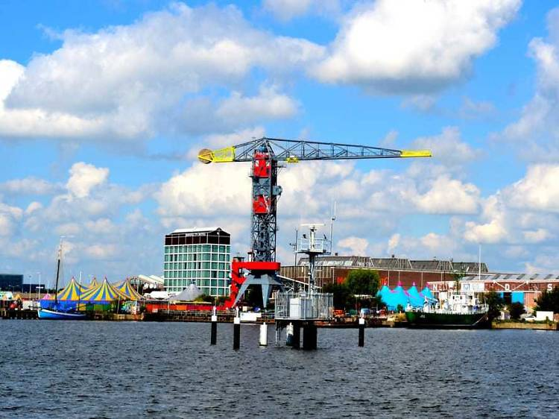](https://www.timeout.com/amsterdam/art/ndsm)](https://www.timeout.com/amsterdam/art/ndsm" \t "_self)

[Photograph: Courtesy Sander B.](https://www.timeout.com/amsterdam/art/ndsm" \t "_self)

**[9. NDSM Wharf](https://www.timeout.com/amsterdam/art/ndsm" \t "_self)**



Formerly the largest shipyard in Amsterdam, NDSM is now a cultural hub and ‘Art City’ that sits at the heart of the capital’s plans to regenerate the vast, industrial Noord area. Just 20 minutes from Centraal via a free ferry, it’s home to a host of restaurants, bars, art studios and performance spaces – not to mention the unmissable IJ-Hallen flea market. Pllek, an organic restaurant complete with a beach, is particularly good, and there’s even a hotel in an old shipping crane. Post-industrial architecture and a creative atmosphere make this a particularly vibrant – and oh-so-hip – hangout.

[**Read more**](https://www.timeout.com/amsterdam/art/ndsm)

[[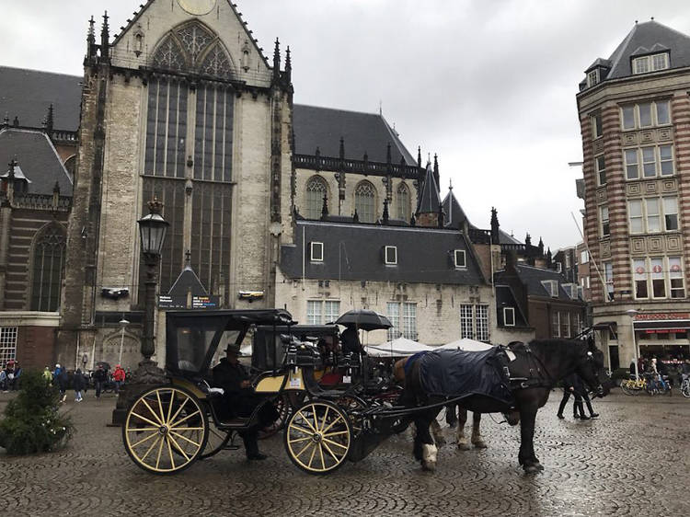](https://www.timeout.com/amsterdam/attractions/koninklijk-paleis-royal-palace)](https://www.timeout.com/amsterdam/attractions/koninklijk-paleis-royal-palace" \t "_blank)

[Photograph: Courtesy Yelp/](https://www.timeout.com/amsterdam/attractions/koninklijk-paleis-royal-palace)[Sohrab O.](https://www.yelp.com/biz_photos/koninklijk-paleis-amsterdam-amsterdam?select=FM77fEMED4evLGtctDXcNw)

**[10. Royal Palace](https://www.timeout.com/amsterdam/attractions/koninklijk-paleis-royal-palace" \t "_blank)**

* **Attractions**
* **Historic buildings and sites**
* **New Side**



It’s worth braving the hordes of Dam Square to set eyes on the Royal Palace, one of the finest examples of classicism anywhere in Europe. Dating from 1665, its opulence particularly appealed to Napoleon, who was the first to use it as a residence – and with marble halls, chandeliers and countless priceless works of art, it’s easy to see why. The palace is open to the public whenever not in official use, and tours take in the magnificent Central Hall and world-famous balcony.

[**Read more**](https://www.timeout.com/amsterdam/attractions/koninklijk-paleis-royal-palace)

ADVERTISING

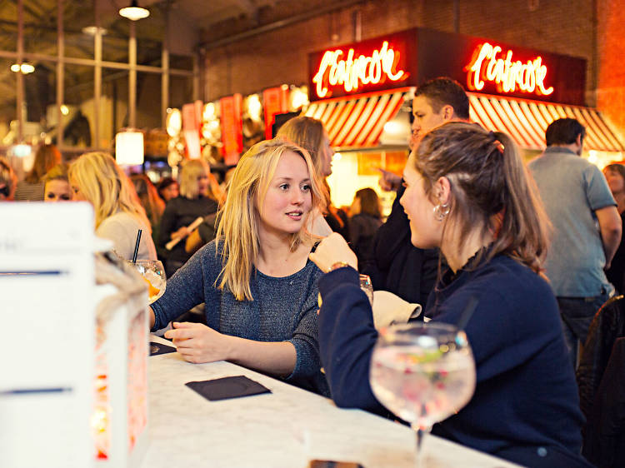

Photograph: Courtesy Typhoon Hospitality

**11. Foodhallen**



This old tram depot has been refashioned as one of Amsterdam’s hottest food destinations. Foodhallen is home to more than 30 stalls and bars, serving everything from Vietnamese street food to tacos. There’s ample seating inside, but they also have a terrace for the warmer months. Those with a sweet tooth are catered for too – don’t miss the delights of Petit Gateau – and drinks wise there are stalls dedicated to craft beer and ales, wine and even gin and tonic.

[**Check website**](http://foodhallen.nl/)

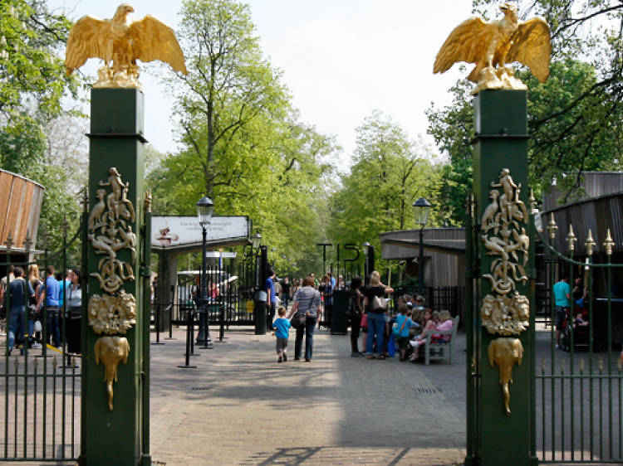

Photograph: Courtesy CC/Wikimedia Commons/[Dejonkheer](https://commons.wikimedia.org/wiki/File:NL-Artis-ingang.jpg" \t "_blank)

**12. Artis Zoo**



One of Europe’s oldest, Amsterdam’s Royal Zoo may be small, but it’s perfectly formed. Here you’ll find big cats, elephants, giraffes and gorillas, plus a brilliant penguin enclosure and a top-notch flamingo pond. But there’s also an impressive aquarium, a planetarium, and Micropia, the only microbe museum in the world. It’s obviously very family-friendly and, if you fancy it, you can even order a picnic or barbecue in advance.

Source: [12 Attractions in Amsterdam Right Now (timeout.com)](https://www.timeout.com/amsterdam/things-to-do/best-attractions-in-amsterdam)